Prelab:
Read the AVR Atmel 328 microcontroller datasheet sections on Timer 1 and on the clock prescaler, pages 112 -141. The pages numbers refer to Revision G of the datasheet dated Feb 2013 as posted on mycourses. “8271G–AVR–02/2013”

Overview:
Much of the code used in microcontrollers depends on having a clear timebase or clock to work from. For example, to precisely control some process, like an elevator motor, it may be necessary to have a clock that is accurate to within a millisecond. If the main processor of the microcontroller is used to keep time, then there will be almost no processor time left to execute the control software. Hardware timers solve this problem. A timer is just a counter, that counts Up, Down or Both ways. If the counter is triggered by a consistant pulse waveform, ex the system clock, the time elapsed counting to a specific value will be; that value times the system clock period. This is the relation between the counter and time.
A hardware timer keeps track of time or measures time intervals, without using any of the main processor’s resources. A hardware timer can be used to generate pulse width modulated signals for controlling a motor without consuming software resources. The hardware timer is an independent unit that just needs to be configured to do its task using registers. It has minimal interaction with the main software loop.

What is this lab about ?
- Using hardware timers in the microcontroller to create pulse width modulated signals without using a software loop that might prevent the processor from running other tasks.
- Learning how to check what values are in a register by printing the register values in binary, hex, and decimal format.
- Configuring a hardware timer in a microcontroller by setting register values.
- Using existing #defined constants such as COM1B1, COM1B0 to make setting the register values easier to read in code.
- Learning how to use the LED on pin 13 to display the digital values from other pins (e.g. pin 10) by using a jumper wire.

How to Succeed With This Lab:
Read the sections of the datasheet. Explore changing a single value in a register and observe what changes in the behavior of the signal. Print the value of each register to see if it has the expected value before it is changed and after it is changed. Use the oscilloscope to measure the pins directly and see what waveform is being produced.
HINT: For the your calculations in this lab, it is helpful to know that the Arduino system clock runs at 16 MHz.
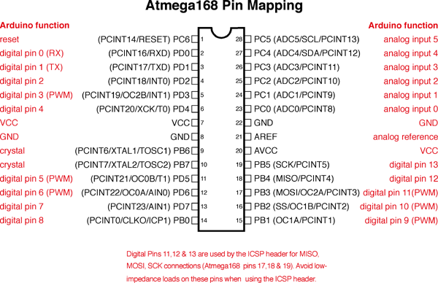

SECTION 1 – Viewing the output of Timer 1 using the oscilloscope

Procedure:
- Load and run the code Lab6_Timer1_p1.
- Connect two oscilloscope probes, one on pin d10, one on pin d9. Set the vertical scale to around 2V/div and the horizontal scale to around 20 msec/div. Vertically offset channel 1 from channel 2 so that you can clearly see the two signals and they are non-overlapping. Your signals should look roughly like the ones in the figure below.
- 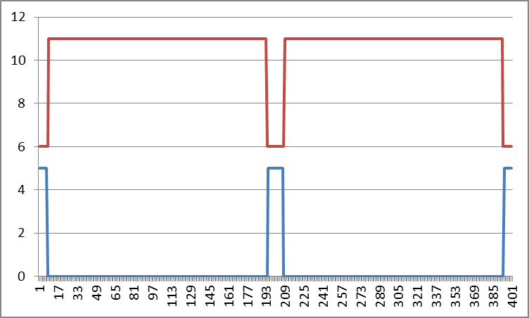
- From the oscilloscope display, which digital pin has the signal that is mostly high, but dips low ~10% of the time? ________ Which pin is mostly low, but goes high ~10% of the time?_________
- Change the value of the register OCR1B, compile and upload the code. Observe how changing the OCR1B value changes waveforms. Are both waveforms affected by the value in OCR1B or just one of the waveforms? Which digital pin’s waveform is affected by changing OCR1B?_______________
- Refer back to the figure that shows the ATMEGA 168 pin mapping for the Arduino. What are all the different pin names that go with digital pin 9? ______________________ What are all the different pin names that go with digital pin 10?______________________
- Change just the value of OCR1B until both waveforms have about the same percent of time that that they are HIGH. What value of OCR1B gives it the same % duty cycle as the other waveform? ________________________. Notice how when the waveforms have the same duty cycle (~10% HIGH, ~90% LOW) there is still a phase difference between the two waveforms. This is in part due to the way the reference values in OCR1A and OCR1B are being compared to a triangle wave that counts up to TOP and counts back down to BOTTOM. It may help to look at the waveforms in the datasheet showing counting up and counting down in phase correct and frequency correct mode.

SECTION 2 – Changing the Timer 1 waveform using COM1B0, COM1B1 bits.
- Now, set the value of OCR1B back to 625 so that you have the original waveforms from the very start of the lab.
- It is possible to make the waveforms on pin d10 and d9 look identical just by changing how the output pins are configured using the Compare Output Mode bits. You will need to read the datasheet section to understand how these bits are used.
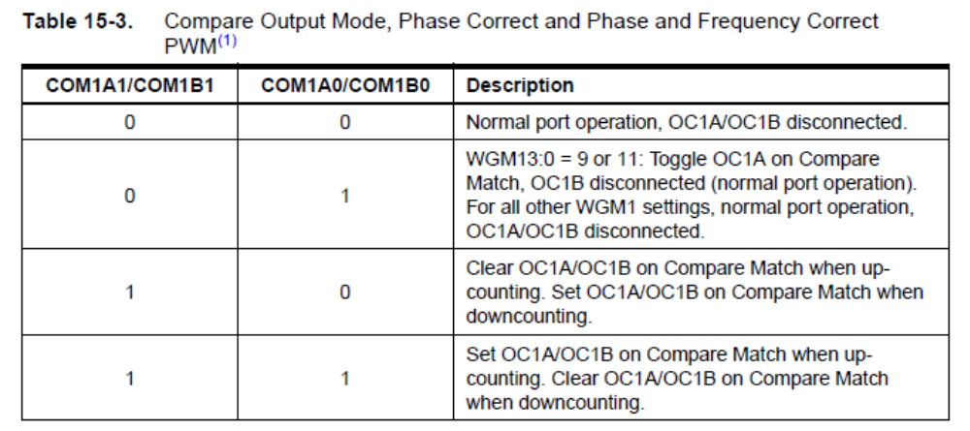
- Changing only the COM1Bx bits, make the output waveforms on d10 and d9 identical. OCR1B must remain unchanged at 625. Show your waveforms to your instructor for a signoff. Why did this do what it did? Does it make sense?
- When you changed the values of the COM1B0 and/or COM1B1 bits, which register (name) was affected? ____________
- Print the binary and hex value of TCCR1A and TCCR1B before and after the changes to COM1Bx bits.
  - Before
    - TCCR1A bin:______________ hex:____________
    - TCCR1B bin:______________ hex:____________
  - After
    - TCCR1A bin:______________ hex:____________
    - TCCR1B bin:______________ hex:____________
Does the change in the register values make sense?

SECTION 3 – Changing the frequency of Timer 1 waveform using ICR1 register.

- Use cursors on the scope to measure the frequency of the signal on pin 10. The period should be about 80 milliseconds for a frequency of 12.5 Hz. By changing only the value of ICR1, modify the frequency to be 10 Hz, (i.e. a period of 100 milliseconds.) What value of ICR1 do you need to use? _______________ Don’t worry about what the duty cycle of the waveform is (i.e. don’t worry about what % of time the signal is HIGH versus LOW).
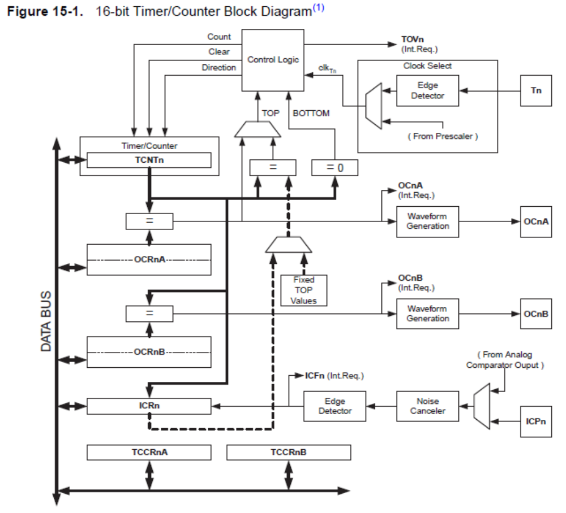
SECTION 4 – Changing the frequency of Timer 1 waveform using clock prescaler

- Configure Timer 1 so that the signal on d10 has a frequency of 1 Hz (a period of 1 second). Try changing the value in the register ICR1 to accomplish this. Are you able to get this to work? You may need to change the clock prescaler as well. At this point, you want to be able calculate out what the register values for ICR1 and the bit values for the clock prescaler should be. To understand how this works, refer to the datasheet. One table that might be helpful is listed below.
- You also might find it helpful to uncomment the line of code in your program that prints the WGMCOMCS1 values
…
Serial.println(F("you can comment out the printing of WGM values to save time"));
//printWGMCOMCS1Values();
…
- 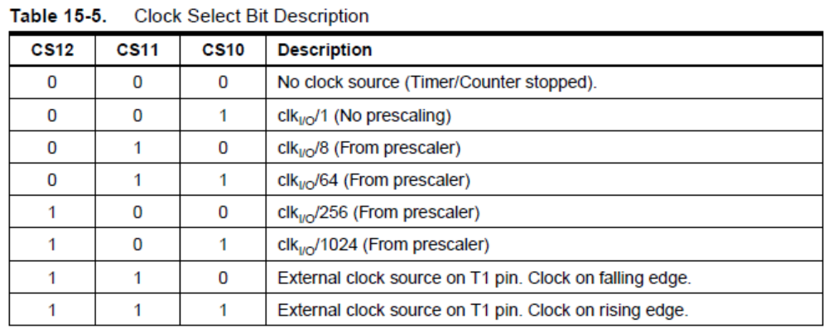
- What register is affected when you change the clock select bits CS12, CS11, CS10? ________________
- Change the values ICR1 and the clock prescaler bits, to get a signal with a frequency of 1 Hz (period of 1 second). What values do you have for each of these registers?
  - ICR1 = ____________ TCCR1A= ____________ TCCR1B = _____________

SECTION 5 – Blinking the LED pin 13 using a hardware timer.

In the first lab, you ran code called “Blink” that turned the pin 13 LED on and off at a one second interval. That code used a delay() function. In this section, you will use a hardware timer do the same thing, however, the LED is on pin 13 and not on pin 10 or pin 9 where the hardware timer is attached. The good news is that there is a way to light the LED on pin 13 using the digital output on pin 10. You can set pin 13’s pin mode to be an INPUT and then place a jumper wire from digital pin 10 to pin 13. Pin 10 is an output and it can drive the LED which still attached to pin 13, even if pin 13’s pin mode is INPUT.

Procedure:
- Make sure your code configures pin 13’s pin mode to be an INPUT.
- Connect a jumper wire from pin 10 to pin 13. Depending upon the duty cycle of the signal on pin 10, the LED might be flashing on and off dimly or brightly.
- Configure the OCR1B register so that the signal on pin 10 has a duty cycle of 50% on, 50% off and period of 1 second. Make any other register adjustments as needed to accomplish this. You should see the LED blinking on for 0.5 sec and off for 0.5 sec.
- Note that while the LED is blinking, you could run additional code at the same time to other tasks, without having the processor stuck on a delay(500); statement for most of the time.

SECTION 6 – Setting PWM frequency to 20 kHz
Pulse Width Modulation (PWM) is widely used to control the speed and direction of DC motors. The pulse width modulation waveforms can be applied directly to the motor, for example using an H-bridge motor drive with high power transistors. Often, it is desirable to perform the pulse width modulation at a frequency that is so high, that humans can not hear it (e.g. freq> 20kHz). If the PWM frequency is low (e.g. 1kHz) then the motor driver can produce an objectionable whining noise.
Procedure:
- Configure Timer 1 so that the frequency is 20kHz and use a clock prescale value so that ICR1 is >= 100. Use the following settings for the compare module COM1A1 = 1, COM1A0 = 1, COM1B1 = 1, COM1B0 = 1. Set the duty cycle on both pins 9 and 10 to be 50% duty cycle. Connect both pin 9 and pin 10 to the oscilloscope so that you can see both waveforms at the same time.
- Fill in the values you used:
  - ICR1 = ____________ OCR1A= ____________ OCR1B = _____________
  - TCCR1A= ____________ TCCR1B = _____________
- Try setting OCR1A = 300 and OCR1B =100 and observe the PWM waveforms on the scope. Try setting OCR1A = 100 and OCR1B =300 and notice how the waveforms change. Place a dc voltmeter between pins 9 and 10 and notice how the dc voltage reading changes between the case where OCR1A = 300, OCR1B =100 and where OCR1A = 100,OCR1B =300. In one case you should see a positive voltage reading, in the other you will see a negative voltage reading. This type of PWM allows you to smoothly control a DC motor’s speed, allowing you to turn the motor forward and backward by applying positive or negative voltage to the terminals of the motor.

Write Up:
There is no write up for this lab, just get the items on the cover sheet (next page) signed off by your lab instructor and submit just the cover sheet in class.
Date: ______________________

Name: ______________________

LABORATORY CHECK OFFS
Section 1  Digital pin that is mostly 90% HIGH? ___________________  Digital pin that is mostly 90% LOW? __________________  Digital pin affected by OCR1B? ___________________  Pin names for d9 ?_________________________________  Pin names for d10 ?________________________________  Value of OCR1B to give same waveform duty cycle?_________  Section 2  Identical waveforms ~10% on duty cycle. No phase offset.  Name of register affected by COM1B1/COM1B0 bits ____________  After:  TCCR1A bin:____________ hex:____________  TCCR1B bin:____________ hex:__________  Section 3  ICR1 for 10 Hz = __________________  Section 4  Name of register affected by CS12 bits?_______________  ICR1 ___________ TCCR1A__________ TCCR1B___________  Section 5  LED 13 is blinking on for 0.5 sec, off for 0.5 sec using Timer1  Section 6  ICR1___________ OCR1A__________ OCR1B ____________  TCCR1A_____0xF0_______ TCCR1B__0x11___________ | ____  ____  ____  ____  ____  ____
Points | ____

